Student Name: Manideep Chitumala
Student id: 24180624
Optimisation Algorithms in Neural Networks
1. Introduction and Motivation
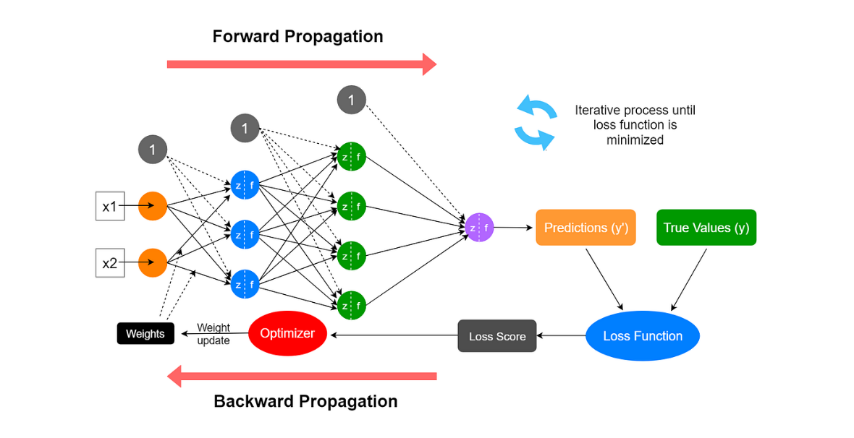
Figure 1: Illustration of neural network training showing the forward pass, loss calculation, and backpropagation process used to update model weights through optimisation.
Neural networks are widely used in machine learning due to their ability to model complex and nonlinear relationships in data. However, their effectiveness depends not only on the network architecture but also on how efficiently the model is trained. At the centre of this process lies optimisation, which determines how the network updates its parameters to minimise prediction error, as illustrated in Figure 1.
Training a neural network involves iteratively adjusting weights based on the gradient of a loss function. While this process forms the foundation of learning, it can be difficult to manage in practice. Problems such as slow convergence, unstable updates, and sensitivity to learning rates can significantly impact model performance. As a result, the choice of optimisation algorithm plays a crucial role in determining how well a network learns.
Several optimisation methods have been developed to address these challenges. Stochastic Gradient Descent (SGD) provides a simple and widely used approach, but it can struggle with efficiency. More advanced algorithms, such as RMSprop and Adam, introduce adaptive strategies to improve stability and convergence.
This tutorial explores how this optimisation algorithms influence training behaviour, convergence speed, and overall performance through both theoretical discussion and experimental analysis.
2. Neural Network Training Overview
Training a neural network involves learning a set of parameters that minimise the difference between predicted outputs and actual targets. This difference is measured using a loss function, such as cross-entropy for classification tasks. The objective of training is to reduce this loss over time so that the model produces accurate predictions.
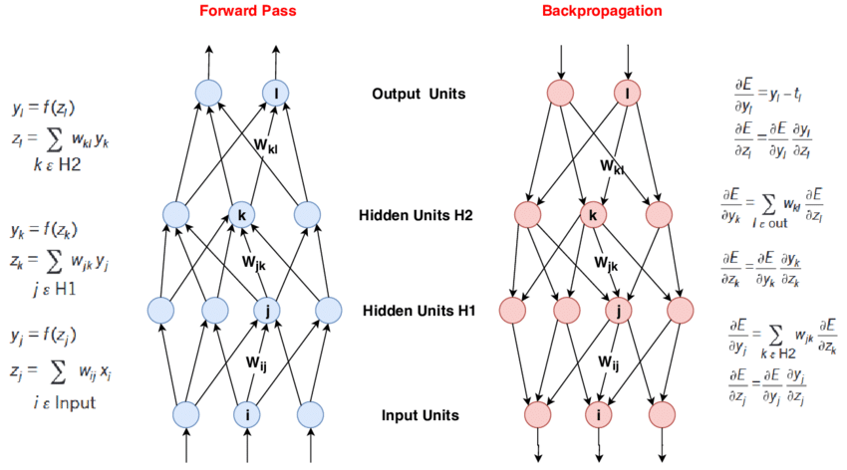
Figure 2: Overview of neural network training showing the forward pass for prediction, loss calculation, and backpropagation used to compute gradients and update model parameters.
The training process is typically divided into two main stages: the forward pass and the backward pass. During the forward pass, input data is passed through the network layer by layer to produce predictions. The loss is then calculated by comparing these predictions with the true labels.
In the backward pass, also known as backpropagation, gradients of the loss function are computed with respect to each parameter in the network. These gradients indicate how each weight should be adjusted to reduce the loss. An optimisation algorithm is then used to update the parameters accordingly.
A key challenge in this process is ensuring that updates are both stable and efficient. If updates are too large, training can become unstable; if they are too small, learning becomes slow. This highlights the importance of choosing appropriate optimisation methods to guide the training process effectively.
3. Optimisation Algorithms
Optimisation algorithms determine how a neural network updates its parameters during training in order to minimise the loss function. While all optimisation methods rely on gradient information, they differ in how they adjust learning rates and handle updates across iterations. These differences can significantly affect convergence speed, stability, and overall model performance.
3.1 Stochastic Gradient Descent (SGD)
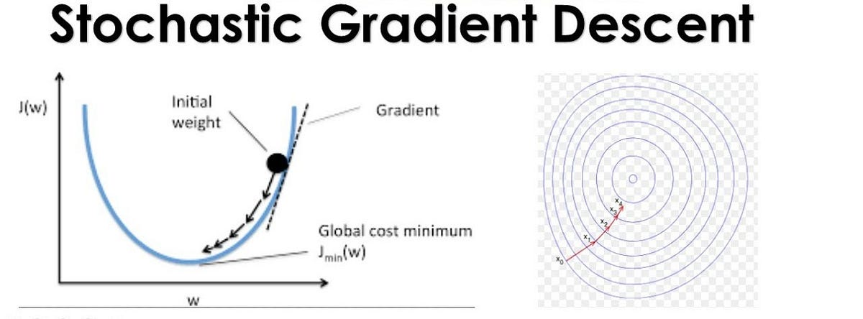
Figure 3.1: SGD optimisation path showing noisy and oscillating updates across the loss surface.
Stochastic Gradient Descent (SGD) is one of the simplest and most widely used optimisation algorithms. Instead of computing gradients using the entire dataset, it updates model parameters using small batches of data. This makes it computationally efficient and suitable for large datasets.
However, SGD can be unstable during training. As shown in Figure 3.1, the update path often oscillates, especially in regions where the loss surface is steep in one direction and flat in another. This can result in slow convergence and sensitivity to the choice of learning rate.
3.2 RMSprop
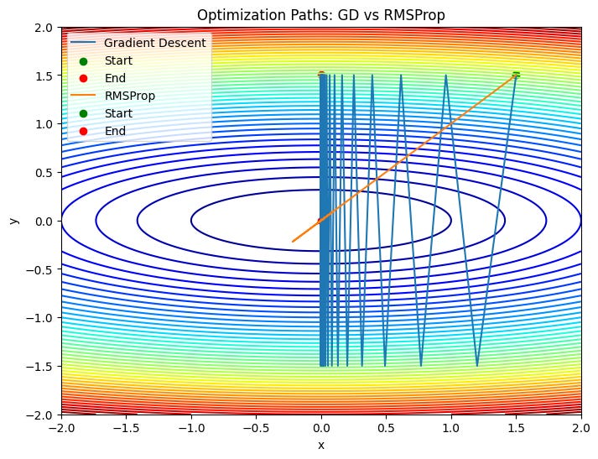
Figure 3.2: RMSprop optimisation showing smoother convergence due to adaptive learning rates.
RMSprop is an adaptive optimisation algorithm designed to address the instability of SGD. It adjusts the learning rate for each parameter individually based on recent gradient magnitudes. This allows the algorithm to take smaller steps in directions with large gradients and larger steps in flatter regions.
As illustrated in Figure 3.2, RMSprop produces a smoother and more stable optimisation path compared to SGD. This often leads to faster convergence and improved training efficiency.
3.3 Adam (Adaptive Moment Estimation)
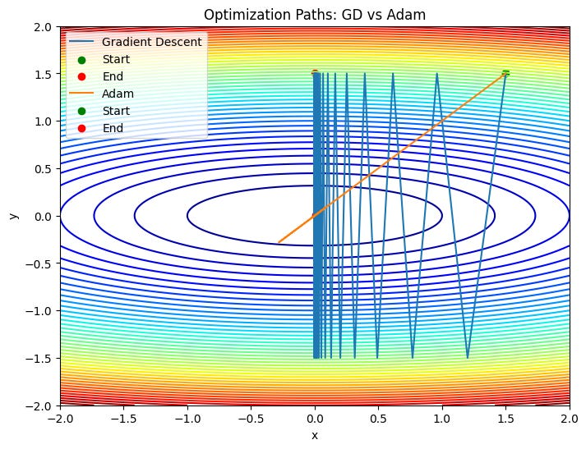
Figure 3.3: Adam optimisation showing fast and stable convergence towards the minimum.
Adam combines the benefits of momentum and adaptive learning rate methods. It maintains moving averages of both gradients and squared gradients, allowing it to adjust updates more effectively over time.
This combination enables Adam to converge faster and more reliably than many other optimisation methods. As shown in Figure 3.3, Adam typically follows a direct and stable path towards the minimum, making it well suited for complex neural network training tasks.
3.4 Comparative Insight
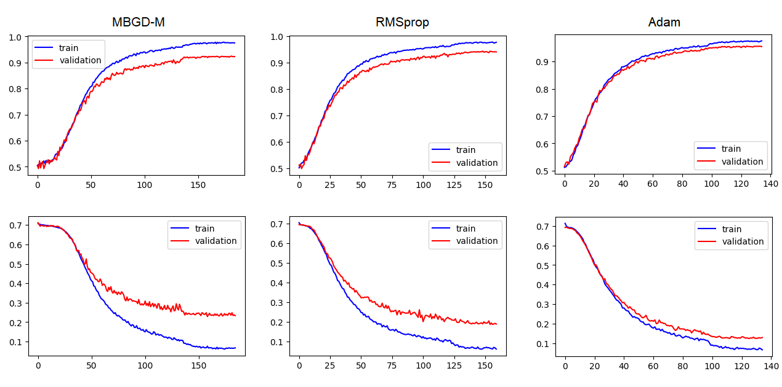
Figure 3.4: Comparison of optimisation algorithms showing differences in convergence behaviour and stability.
Comparing these optimisation algorithms highlights key differences in their behaviour. SGD is simple but can be slow and unstable. RMSprop improves stability by adapting learning rates, while Adam combines multiple strategies to achieve faster and more reliable convergence.
In practice, Adam is often preferred due to its efficiency and ease of use. However, SGD may still perform well in certain cases, particularly when carefully tuned. These differences are further explored in the experimental results presented later in this tutorial.
4. Training Challenges in Neural Networks
Training neural networks can be challenging due to several factors that affect how effectively the model learns. One of the most common issues is the vanishing gradient problem, where gradients become extremely small as they propagate through deeper layers. This prevents earlier layers from updating effectively, slowing down learning.
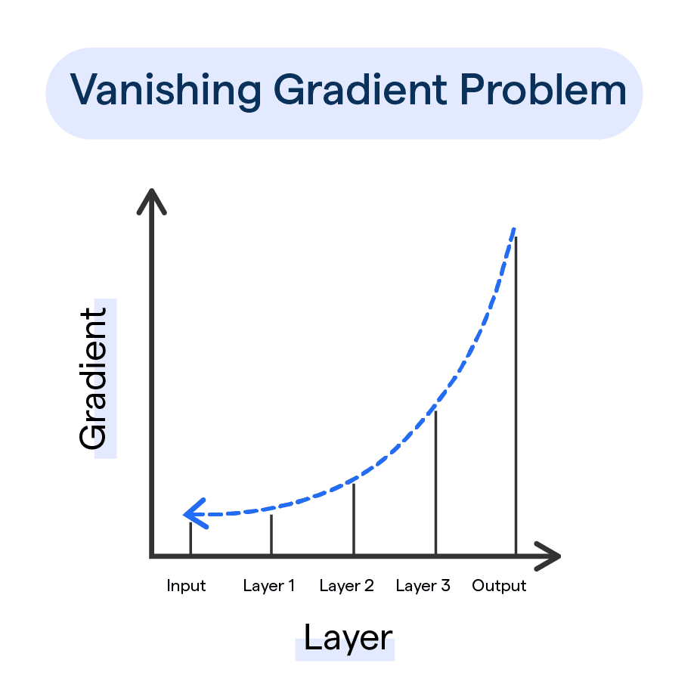
Figure 4: Illustration of common training challenges in neural networks, including vanishing and exploding gradients.
On the other hand, gradients can sometimes become excessively large, leading to the exploding gradient problem. This can cause unstable updates and make the training process diverge. Both issues highlight the importance of maintaining balanced and stable parameter updates during optimisation.
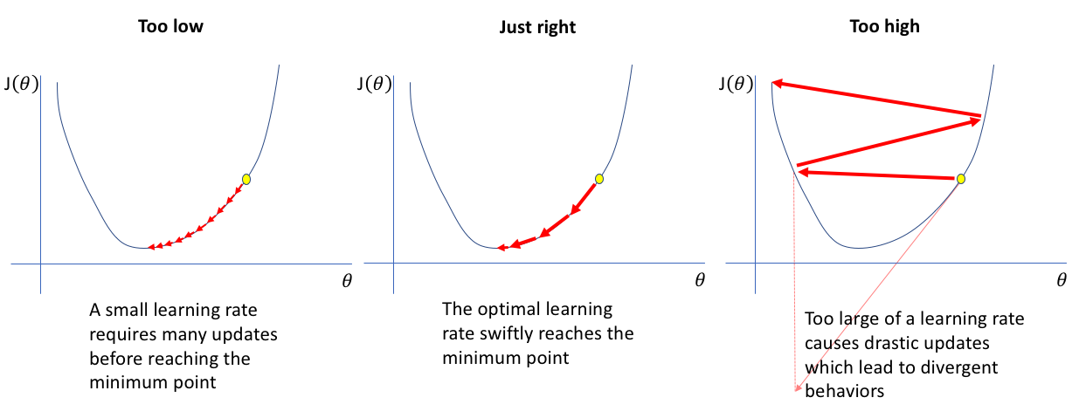
Figure 4.1: the effect of different learning rates on convergence.
Another key challenge is selecting an appropriate learning rate. If the learning rate is too high, the model may overshoot the optimal solution and fail to converge. If it is too low, training becomes very slow and may get stuck in suboptimal regions.
These challenges are closely related to the choice of optimisation algorithm. More advanced methods, such as RMSprop and Adam, are designed to address these issues by adapting learning rates and stabilising updates throughout the training process.
5. Experimental Study on Optimisation Algorithms
To evaluate the effect of different optimisation algorithms, a series of experiments was conducted using a nonlinear dataset generated with the make_moons function. This dataset consists of two interleaving classes and is well suited for analysing how neural networks learn complex decision boundaries.
The dataset contained 600 samples and was split into 80% training and 20% testing sets. Feature scaling was applied using standardisation to ensure stable optimisation. A neural network with two hidden layers (16 neurons each) and ReLU activation was used for all experiments. To ensure a fair comparison, only the optimisation algorithm was changed, while all other parameters were kept constant.
5.1 Training Loss Comparison
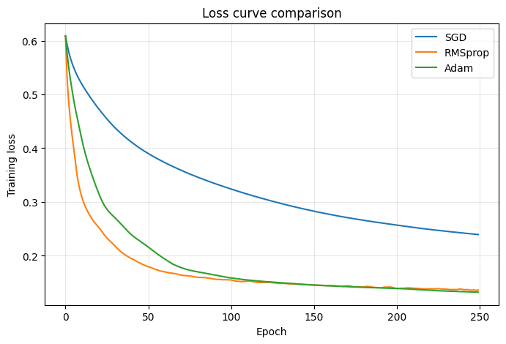
Figure 5.1: Training loss curves for SGD, RMSprop, and Adam.
The training loss curves reveal clear differences in convergence behaviour. SGD shows a noisy and fluctuating loss pattern, indicating unstable updates during training. Although the loss decreases over time, the progress is relatively slow and less consistent.
RMSprop produces a smoother loss curve, reflecting more stable updates. This behaviour results from its ability to adapt learning rates based on recent gradient values.
Adam demonstrates the fastest and most stable convergence. The loss decreases rapidly during the early stages and continues to improve steadily, indicating efficient optimisation.
5.2 Accuracy Comparison
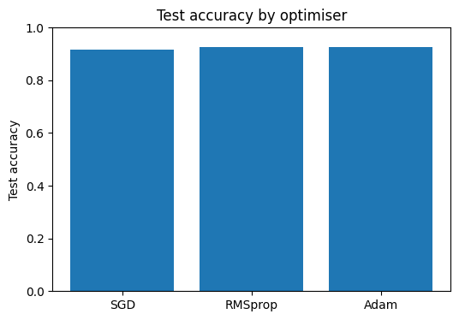
Figure 5.2: Test accuracy comparison of optimisation algorithms.
The accuracy results further highlight the differences between optimisation methods. Adam achieves the highest test accuracy, followed closely by RMSprop, while SGD performs slightly worse.
This suggests that stable and efficient optimisation leads to improved generalisation. While the difference between RMSprop and Adam is relatively small, SGD may require careful tuning to achieve similar performance.
5.3 Decision Boundary Analysis
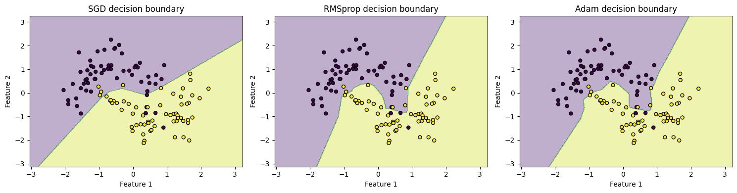
Figure 5.3: Decision boundaries produced by SGD, RMSprop, and Adam.
Visualising the decision boundaries provides additional insight into model behaviour. The boundary produced by SGD appears less smooth and slightly irregular, reflecting its unstable updates.
RMSprop produces a more refined boundary that better captures the structure of the data. Adam generates the most accurate and well-defined boundary, closely following the nonlinear shape of the dataset.
This demonstrates that more advanced optimisation methods can improve both learning efficiency and model quality.
5.4 Summary of Results
The experimental findings show that:
- SGD is simple but exhibits slower and less stable convergence
- RMSprop improves stability through adaptive learning rates
- Adam provides the fastest convergence and best overall performance
These results highlight that the choice of optimisation algorithm has a significant impact on both training efficiency and final model performance.
6. Code and Repository
The complete implementation of the multilayer neural network experiments, including the dataset and Jupyter Notebook, is available at the following GitHub repository:
(add your github link)
The repository contains all the necessary files required to reproduce the experiments presented in this report, including data generation, model implementation, and visualisation of results. A README file provides instructions for running the code.

7. Analysis of Optimisation Behaviour
The experimental results provide clear evidence that the choice of optimisation algorithm has a significant impact on both training dynamics and model performance. While all three methods—SGD, RMSprop, and Adam—are capable of reducing the loss and achieving reasonable accuracy, their behaviour during training differs substantially.
A key observation is that SGD exhibits slower and less stable convergence. The fluctuating loss curve suggests that updates are inconsistent, particularly in regions where the loss surface varies across different directions. This behaviour occurs because SGD applies the same learning rate to all parameters, without adapting to the structure of the optimisation landscape. As a result, it can struggle to move efficiently towards the optimal solution.
In contrast, RMSprop improves stability by adapting learning rates based on recent gradient magnitudes. This allows the model to take smaller steps in steep directions and larger steps in flatter regions, leading to smoother convergence. The experimental results confirm this behaviour, as the loss curve becomes more consistent and the decision boundary better reflects the structure of the dataset.
Adam further enhances this process by combining adaptive learning rates with momentum. By maintaining running averages of both gradients and squared gradients, Adam is able to accelerate convergence while reducing oscillations. This explains why it achieves the fastest loss reduction and produces the most accurate decision boundary in the experiments.
Interestingly, although Adam performs best overall, the difference between Adam and RMSprop is relatively small. This suggests that both adaptive methods are effective, and the choice between them may depend on the specific problem. In some cases, simpler methods like SGD may still generalise well when carefully tuned, despite slower convergence.
Overall, the results highlight that optimisation algorithms do not simply affect training speed—they also influence how effectively a model learns meaningful patterns. Selecting an appropriate optimiser is therefore a critical step in designing reliable neural network models.
8. Practical Guidelines for Using Optimisation Algorithms
Selecting an appropriate optimisation algorithm is an important step in training neural networks effectively. Based on the results of this study, a practical approach is to begin with adaptive methods such as Adam, as they generally provide fast and stable convergence without extensive tuning. This makes them suitable for most problems, particularly when working with complex or noisy datasets.
RMSprop can be a useful alternative when similar stability is required, especially in cases where slightly different convergence behaviour is preferred. Although SGD is simpler, it may require careful adjustment of the learning rate and training parameters to achieve competitive performance. However, it can still be effective in well-controlled settings or when computational simplicity is important.
In practice, it is advisable to experiment with multiple optimisation methods and compare their performance. Model design should be guided by observed results rather than assumptions, ensuring both efficient training and good generalisation.
9. Accessibility Considerations
This tutorial has been designed with accessibility in mind to ensure that the content is clear and usable for a wide range of users. Visual elements such as plots and decision boundaries have been created with clear labels, simple layouts, and sufficient contrast to improve readability. Where possible, colour choices are kept distinguishable to support users with colour vision deficiencies.
Each figure is accompanied by a descriptive caption, allowing readers to understand the key message even without detailed visual interpretation. The structure of the report follows a logical progression, making it easier to navigate and suitable for screen readers.
In addition, the code provided in the accompanying notebook is organised and commented to support reproducibility. This allows users with different levels of experience to follow the workflow and replicate the results. These considerations help ensure that the tutorial remains accessible, informative, and practical for a diverse audience.
10. Conclusion
This tutorial explored the impact of optimisation algorithms on neural network training, focusing on Stochastic Gradient Descent (SGD), RMSprop, and Adam. Through both theoretical discussion and experimental evaluation, it was shown that optimisation methods significantly influence convergence speed, training stability, and overall model performance.
The results demonstrated that SGD, while simple and widely used, can suffer from slow and unstable convergence. RMSprop improves this behaviour by adapting learning rates based on gradient information, leading to smoother training. Adam further enhances performance by combining adaptive learning with momentum, allowing it to converge more quickly and reliably.
The experimental findings confirmed that Adam achieved the best overall performance, producing faster loss reduction, higher accuracy, and more refined decision boundaries. However, the relatively small difference between Adam and RMSprop suggests that multiple adaptive methods can be effective depending on the problem.
Overall, this study highlights that optimisation is not just a technical detail, but a critical factor in neural network design. Selecting an appropriate optimisation algorithm can significantly improve both efficiency and model quality. Future work could explore additional optimisers, larger datasets, or deeper architectures to further understand these effects.
11. References
Bishop, C. M. (2006). Pattern Recognition and Machine Learning. Springer.
Kingma, D. P., & Ba, J. (2015). Adam: A Method for Stochastic Optimization. International Conference on Learning Representations (ICLR).
Hinton, G., Srivastava, N., & Swersky, K. (2012). Lecture 6e: RMSprop – Divide the gradient by a running average of its recent magnitude. Coursera Neural Networks for Machine Learning.
IEEE (2019). Multilayer Perceptron Based Models. Available at: https://ieeexplore.ieee.org/document/8819775
ResearchGate (n.d.). Multilayer Perceptron and Neural Networks. Available at: https://www.researchgate.net/publication/228340819_Multilayer_perceptron_and_neural_networks
GeeksforGeeks (n.d.). Optimization Algorithms in Machine Learning. Available at: https://www.geeksforgeeks.org/

